**Project Document: Inter-Process Communication (IPC) Framework**

**Contents**

1. Project Overview…………………………………………………………………………………..1

2 Objective…………………………………………………………………………………….2

3. Scope 3

Target Environment……………………………………………………………………………..3

Primary Audience……………………………………………………………………………….3

Programming Language……………………………………………………………………….3

4. Features…………………………………………………………………………………………….4

Message Passing………………………………………………………………………………4

Synchronization………………………………………………………………………………...4

Shared Memory………………………………………………………………………………..4

Process Creation……………………………………………………………………………….4

Inter-Process Signaling………………………………………………………………………..4

Pipes for Streamed Communication…………………………………………………………4

Multi-Process Communication………………………………………………………………..4

Concurrency Management…………………………………………………………………..4

Error Handling and Logging…………………………………………………………………4

Custom Protocol……………………………………………………………………………….4

Security Features………………………………………………………………………………4

Timeout and Retransformation……………………………………………………………….4

Dynamic Configuration……………………………………………………………………….4

Testing and Simulation Toots………………………………………………………………...4

5. Functional Requirements…………………………………………………………………..5

Message queue Communication……………………………………………………5

Semaphore-Based Synchronization………………………………………………..5

Shared Memory Access………………………………………………………………..5

Process Creation and Management……………………………………………………5

Inter-process Signaling…………………………………………………………………5

Pipes for Streamed Communication……………………………………………………5

Multi-Process Communication…………………………………………………………..5

Concurrency Management………………………………………………………………5

Error Handling…………….………………………………………………………………...5

Custom Protocol…………………………………………………………………………….5

Security Mechanism…………………………………………………………………………5

6. Non-functional Requirements 6

Performance………………………………………………………………………………...6

Scalability……………………………………………………………………………………6

Reliability…………………………………………………………………………………….6

Usability……………………………………………………………………………………..6

Security……………………………………………………………………………………..6

Maintainability………………………………………………………………………………6

Compatibility………………………………………………………………………………..6

Portability……………………………………………………………………………………6

Resource Efficiency………………………………………………………………………..6

7. User Roles………………………………………………………………………………….7

System Administrator………………………………………………………………………7

Regular User……………………………………………………………………………….7

8. Input/Output Specifications…………………………………………………………………8

Input…………………………………………………………………………………………8

Output……………………………………………………………………………………….8

9. Challenges………………………………………………………………………………….9

Resource Management…………………………………………………………………...9

Concurrency Control………………………………………………………………………9

Error Handling……………………………………………………………………………..9

10.System Design…………………………………………………………………………………..10

Process A…………………………………………………………………………………10

Process B…………………………………………………………………………………10

11. Skeleton Code Structure…………………………………………………………………11

ipc.h………………………………………………………………………………………..11

ipc.cpp……………………………………………………………………………………..11

ipc_test.cpp……………………………………………………………………………….11

Makefile……………………………………………………………………………………11

11. Testing and Validation……………………………………………………………………12

Unit Testing………………………………………………………………………..11

Concurrency Testing……………………………………………………………..11

Integration Testing………………………………………………………………11

12. Documentation…………………………………………………………………………..12

Code Documentation………………………………………………………………………..12

User Guide……………………………………………………………………………………12

13. Milestones………………………………………………………………………………..13

Phase1………………………………………………………………………………………..13

Phase 2……………………………………………………………………………………….13

Phase 3……………………………………………………………………………………….13

Phase 4……………………………………………………………………………………….13

Phase 5……………………………………………………………………………………….13

Phase 6……………………………………………………………………………………….13

12. References……………………………………………………………………………….14

POSIX IPC Documentation…………………………………………………………………14

Message Queues……………………………………………………………………………14

Shared Memory………………………………………………………………………………14

Semaphores………………………………………………………………………………….14

# **1. Project Overview**

**Project Title: Inter-Process Communication (IPC) Framework**

The **IPC (Inter-Process Communication) Framework** project is about creating tools that help different computer programs work together smoothly on a Linux system. These tools allow programs to share information and coordinate their actions, even if they are running on different computers.

**To achieve this, the project uses:**

* **Message Queues**: A way for one program to leave a message for another program to pick up later.
* **Shared Memory**: A common space where programs can read and write information directly.
* **Semaphores**: A system that ensures programs take turns using shared resources, avoiding conflicts.

# **2. Objective:**

**Enable Program Communication:** Allow different programs to talk to each other easily.

**Share Data Efficiently:** Let programs access and share information directly.

**Avoid Conflicts:** Ensure programs don’t interfere with each other when using shared resources.

**Be Flexible:** Create tools that can be used in various larger systems.

# **3. Scope**

### **Target Environment**

* **Linux-based operating systems.**

### **Primary Audience**

* System programmers, developers working on multi-process applications, and students learning about process communication.

### **Programming Language**

* C++

### **Libraries**

* POSIX IPC mechanisms (message queues, shared memory, semaphores)

# 

# **4. Features:**

### Message Passing:

* **Feature**: Enable communication between processes using message queues.
* **Description**: Processes can send and receive messages using a structured message queue system. Each message has a specific type, allowing selective reception of messages by type.

### Synchronization:

* **Feature**: Use of Semaphores.
* **Description**: Semaphores are used to synchronize access to shared resources between multiple processes. This prevents race conditions by controlling the order of execution.

### Shared Memory:

* **Feature**: Memory Sharing Between Processes.
* **Description**: Processes can communicate by sharing a block of memory, allowing them to exchange data quickly. Shared memory is typically faster than message queues or pipes for large data transfers.

### Process Creation:

* **Feature**: Forking New Processes.
* **Description**: The framework supports creating child processes using the fork() system call. The child processes can execute different parts of the application or handle separate tasks.Pipes for Streamed Communication:
* **Feature**: Unidirectional and Bidirectional Pipes.
* **Description**: The framework supports the use of pipes for streaming data between processes. Pipes can be used for one-way or two-way communication, enabling processes to exchange information in a producer-consumer model.

### Multi-Process Communication:

* **Feature**: Communication Across Multiple Processes.
* **Description**: The framework allows for communication not just between two processes but across multiple processes, using a combination of message queues, shared memory, and semaphores.

### Concurrency Management:

* **Feature**: Concurrent Processing.
* **Description**: Support for concurrent execution of processes, allowing multiple tasks to run simultaneously while managing shared resources.

### Testing and Simulation Tools:

* **Feature**: Built-in Testing and Simulation Tools.
* **Description**: Include tools to simulate different IPC scenarios, test the robustness of the system, and evaluate the performance of the communication mechanisms under various conditions.

# 

# **Functional Requirements**

### Message Queue Communication:

* + **Description**: The system should enable processes to communicate using message queues, allowing messages to be sent and received based on message types.
  + **Priority**: High

### Semaphore-Based Synchronization:

* + **Description**: The system must implement semaphores to control access to shared resources and ensure that processes are synchronized correctly.
  + **Priority**: High

### Shared Memory Access:

* + **Description**: Processes should be able to share a memory space for fast data exchange, with support for read and write operations.
  + **Priority**: High

### Process Creation and Management:

* + **Description**: The system should allow for the creation of new processes using fork(), manage their execution, and handle communication between parent and child processes.
  + **Priority**: High

### Inter-Process Signaling:

* + **Description**: The system should support signaling between processes, allowing processes to send and handle signals like SIGINT and SIGTERM.
  + **Priority**: Medium

### Pipe Communication:

* + **Description**: The system should support unidirectional and bidirectional pipes for streaming data between processes.
  + **Priority**: Medium

# **Non-Functional Requirements**

### Performance:

* + **Description**: The system should have low latency and high throughput for message passing, ensuring that communication between processes occurs quickly and efficiently.
  + **Priority**: High

### Scalability:

* + **Description**: The system should be able to handle a large number of processes and high volumes of data without significant performance degradation.
  + **Priority**: Medium

### Reliability:

* + **Description**: The IPC framework should be reliable, ensuring that messages are not lost, and processes are correctly synchronized even under heavy load.
  + **Priority**: High

### Usability:

* + **Description**: The framework should be easy to use, with clear documentation and examples, making it accessible for developers to implement IPC in their applications.
  + **Priority**: Medium

### Security:

* + **Description**: The framework should protect against unauthorized access to shared resources and ensure data integrity and confidentiality.
  + **Priority**: High

### Maintainability:

* + **Description**: The codebase should be well-documented and modular, allowing for easy updates and extensions to the system.
  + **Priority**: Medium

# **5. User Roles**

### System Administrator

* Full access to create, manage, and terminate IPC objects.

### Regular User

* Restricted access based on permissions, primarily focused on using the IPC mechanisms.

# **6. Input/Output Specifications**

### Input:

* Messages, data segments, and synchronization signals from various processes.

### Output:

* Messages delivered to intended recipients, synchronized access to shared resources.

# **7. Challenges**

### Resource Management:

* Efficiently managing and cleaning up IPC objects to prevent resource leakage.

### Concurrency Control:

* Implementing robust synchronization mechanisms to avoid race conditions and deadlocks.

### Error Handling:

* Providing clear error messages and recovery options in case of failures.

# 

# **8. System Design**

### Process A

* Send a message to **Message Queue**.
* Writes data to **Shared Memory**.
* Signals **Semaphore** after writing to **Shared Memory**.

**Process A**

**Message Queue**

**Shared Memory**

**Semaphore**

### **Process B**

* Waits for a signal from **Semaphore** before accessing **Shared Memory**.
* Reads data from **Shared Memory**.
* Receives a message from **Message Queue**

**Semaphore**

**Shared Memory**

**Message Queue**

**Process B**

### **Process A**

It is responsible for sending data to the Message Queue and writing data to Shared Memory. Once it has written to shared memory, it signals the Semaphore to notify Process B that the data is ready.

### **Process B**

**It** waits for the semaphore signal, ensuring that it only accesses the Shared Memory when it is safe to do so. After reading the data, Process B can also receive messages from the Message Queue.

# 

# 

# **9. Skeleton Code Structure**

### ipc.h

#ifndef IPC_H // Check if IPC_H is not defined

#define IPC_H // Define IPC_H

#include <iostream>

#include <sys/ipc.h>

#include <sys/msg.h>

#include <sys/shm.h>

#include <sys/sem.h>

#include <cstring>

#include <unistd.h>

// define Message Structure

struct Message {

long msg_type;

char msg_text[100];

};

// Message Queue Functions

int initMessageQueue(key_t key);

int sendMessage(int msgid, const Message& message);

int receiveMessage(int msgid, Message& message, long msg_type);

// Shared Memory Functions

int initSharedMemory(key_t key, size_t size);

void* attachSharedMemory(int shmid);

// Semaphore Functions-

int initSemaphore(key_t key, int num_sems);

int semaphoreWait(int semid, int sem_num);

int semaphoreSignal(int semid, int sem_num);

// IPC Framework Initialization

void initIPCFramework();

// Testing Functions

void test_message_queue();

void test_shared_memory();

void test_semaphore();

void test_concurrency();

void test_integration();

#endif // IPC_H

### ipc.cpp

#include <sys/wait.h>

#include <iostream>

#include <cstring>

#include <cstdlib>

#include <unistd.h>

// Message Queue Functions

int initMessageQueue(key_t key) {

int msgid = msgget(key, 0666 | IPC_CREAT);

if (msgid == -1) {

perror("msgget");

exit(EXIT_FAILURE);

}

return msgid;

}

int sendMessage(int msgid, const Message& message) {

if (msgsnd(msgid, &message, sizeof(message.msg_text), 0) == -1) {

perror("msgsnd");

return -1;

}

return 0;

}

int receiveMessage(int msgid, Message& message, long msg_type) {

if (msgrcv(msgid, &message, sizeof(message.msg_text), msg_type, 0) == -1) {

perror("msgrcv");

return -1;

}

return 0;

}

// Shared Memory Functions

int initSharedMemory(key_t key, size_t size) {

int shmid = shmget(key, size, 0666 | IPC_CREAT);

if (shmid == -1) {

perror("shmget");

exit(EXIT_FAILURE);

}

return shmid;

}

void* attachSharedMemory(int shmid) {

void* shmaddr = shmat(shmid, NULL, 0);

if (shmaddr == (void*)-1) {

perror("shmat");

exit(EXIT_FAILURE);

}

return shmaddr;

}

// Semaphore Functions

int initSemaphore(key_t key, int num_sems) {

int semid = semget(key, num_sems, 0666 | IPC_CREAT);

if (semid == -1) {

perror("semget");

exit(EXIT_FAILURE);

}

// Initialize semaphore to 1 (binary semaphore)

semctl(semid, 0, SETVAL, 1);

return semid;

}

int semaphoreWait(int semid, int sem_num) {

struct sembuf sops = {static_cast<unsigned short>(sem_num), -1, 0};

if (semop(semid, &sops, 1) == -1) {

perror("semop wait");

return -1;

}

return 0;

}

int semaphoreSignal(int semid, int sem_num) {

struct sembuf sops = {static_cast<unsigned short>(sem_num), 1, 0};

if (semop(semid, &sops, 1) == -1) {

perror("semop signal");

return -1;

}

return 0;

}

// IPC Framework Initialization

void initIPCFramework() {

key_t key = ftok("progfile", 65);

int msgid = initMessageQueue(key);

int shmid = initSharedMemory(key, 1024);

int semid = initSemaphore(key, 1);

Message message;

message.msg_type = 1;

strcpy(message.msg_text, "Hello from Message Queue!");

sendMessage(msgid, message);

receiveMessage(msgid, message, 1);

std::cout << "Received Message: " << message.msg_text << std::endl;

char* shared_data = static_cast<char*>(attachSharedMemory(shmid));

strcpy(shared_data, "Shared Memory Data");

semaphoreWait(semid, 0);

std::cout << "Shared Memory Content: " << shared_data << std::endl;

semaphoreSignal(semid, 0);

}

// Testing Functions

void test_message_queue() {

key_t key = ftok("progfile", 65);

int msgid = initMessageQueue(key);

Message message;

message.msg_type = 1;

strcpy(message.msg_text, "Test Message Queue");

sendMessage(msgid, message);

receiveMessage(msgid, message, 1);

std::cout << "Message Queue Test - Received: " << message.msg_text << std::endl;

}

void test_shared_memory() {

key_t key = ftok("progfile", 65);

int shmid = initSharedMemory(key, 1024);

char* shared_data = static_cast<char*>(attachSharedMemory(shmid));

strcpy(shared_data, "Test Shared Memory");

std::cout << "Shared Memory Test - Content: " << shared_data << std::endl;

}

void test_semaphore() {

key_t key = ftok("progfile", 65);

int semid = initSemaphore(key, 1);

std::cout << "Waiting on semaphore." << std::endl;

if (semaphoreWait(semid, 0) == -1) {

std::cerr << "Semaphore wait failed." << std::endl;

return;

}

std::cout << "Semaphore acquired, entering critical section." << std::endl;

// Simulate some work in the critical section

sleep(1); // Replace with actual work

if (semaphoreSignal(semid, 0) == -1) {

std::cerr << "Semaphore signal failed." << std::endl;

return;

}

std::cout << "Semaphore released, exiting critical section." << std::endl;

}

void test_concurrency() {

pid_t pid = fork();

if (pid == 0) {

std::cout << "Child process starting tests." << std::endl;

test_message_queue();

test_shared_memory();

test_semaphore();

std::cout << "Child process tests completed." << std::endl;

exit(0);

} else if (pid > 0) {

std::cout << "Parent process waiting for child." << std::endl;

test_message_queue();

test_shared_memory();

test_semaphore();

wait(NULL);

std::cout << "Parent process tests completed." << std::endl;

} else {

perror("fork");

exit(EXIT_FAILURE);

}

}

void test_integration() {

std::cout << "Integration test starting." << std::endl;

initIPCFramework();

std::cout << "Integration test completed." << std::endl;

### **ipc_test.cpp**

#include "../include/ipc.h"

#include <iostream>

#include <cstring>

#include <cstdlib>

#include <sys/wait.h>

#include <unistd.h>

int main() {

test_message_queue();

test_shared_memory();

test_semaphore();

test_concurrency();

test_integration();

return 0;

}

### **Makefile**

**# Default target**

all: $(TARGET)

**# Rule to build the executable**

$(TARGET): $(OBJ_FILES)

$(CC) $(CFLAGS) -o $@ $^

**# Rule to build object files**

$(BUILD_DIR)/%.o: $(SRC_DIR)/%.cpp

mkdir -p $(BUILD_DIR)

$(CC) $(CFLAGS) -c $< -o $@

**# Clean rule to remove build artifacts**

clean:

rm -rf $(BUILD_DIR) $(TARGET)

### **OUTPUT**

### 

rm -rf $(BUILD_DIR) $(TARGET)

# **9. Testing and Validation**

### Unit Testing

* Test individual IPC mechanisms (message queues, shared memory, semaphores) to ensure correctness.

### Concurrency Testing

* Simulate multiple processes interacting with the framework to ensure synchronization and data integrity.

### Integration Testing

* Verify the framework works seamlessly as a unified IPC solution.

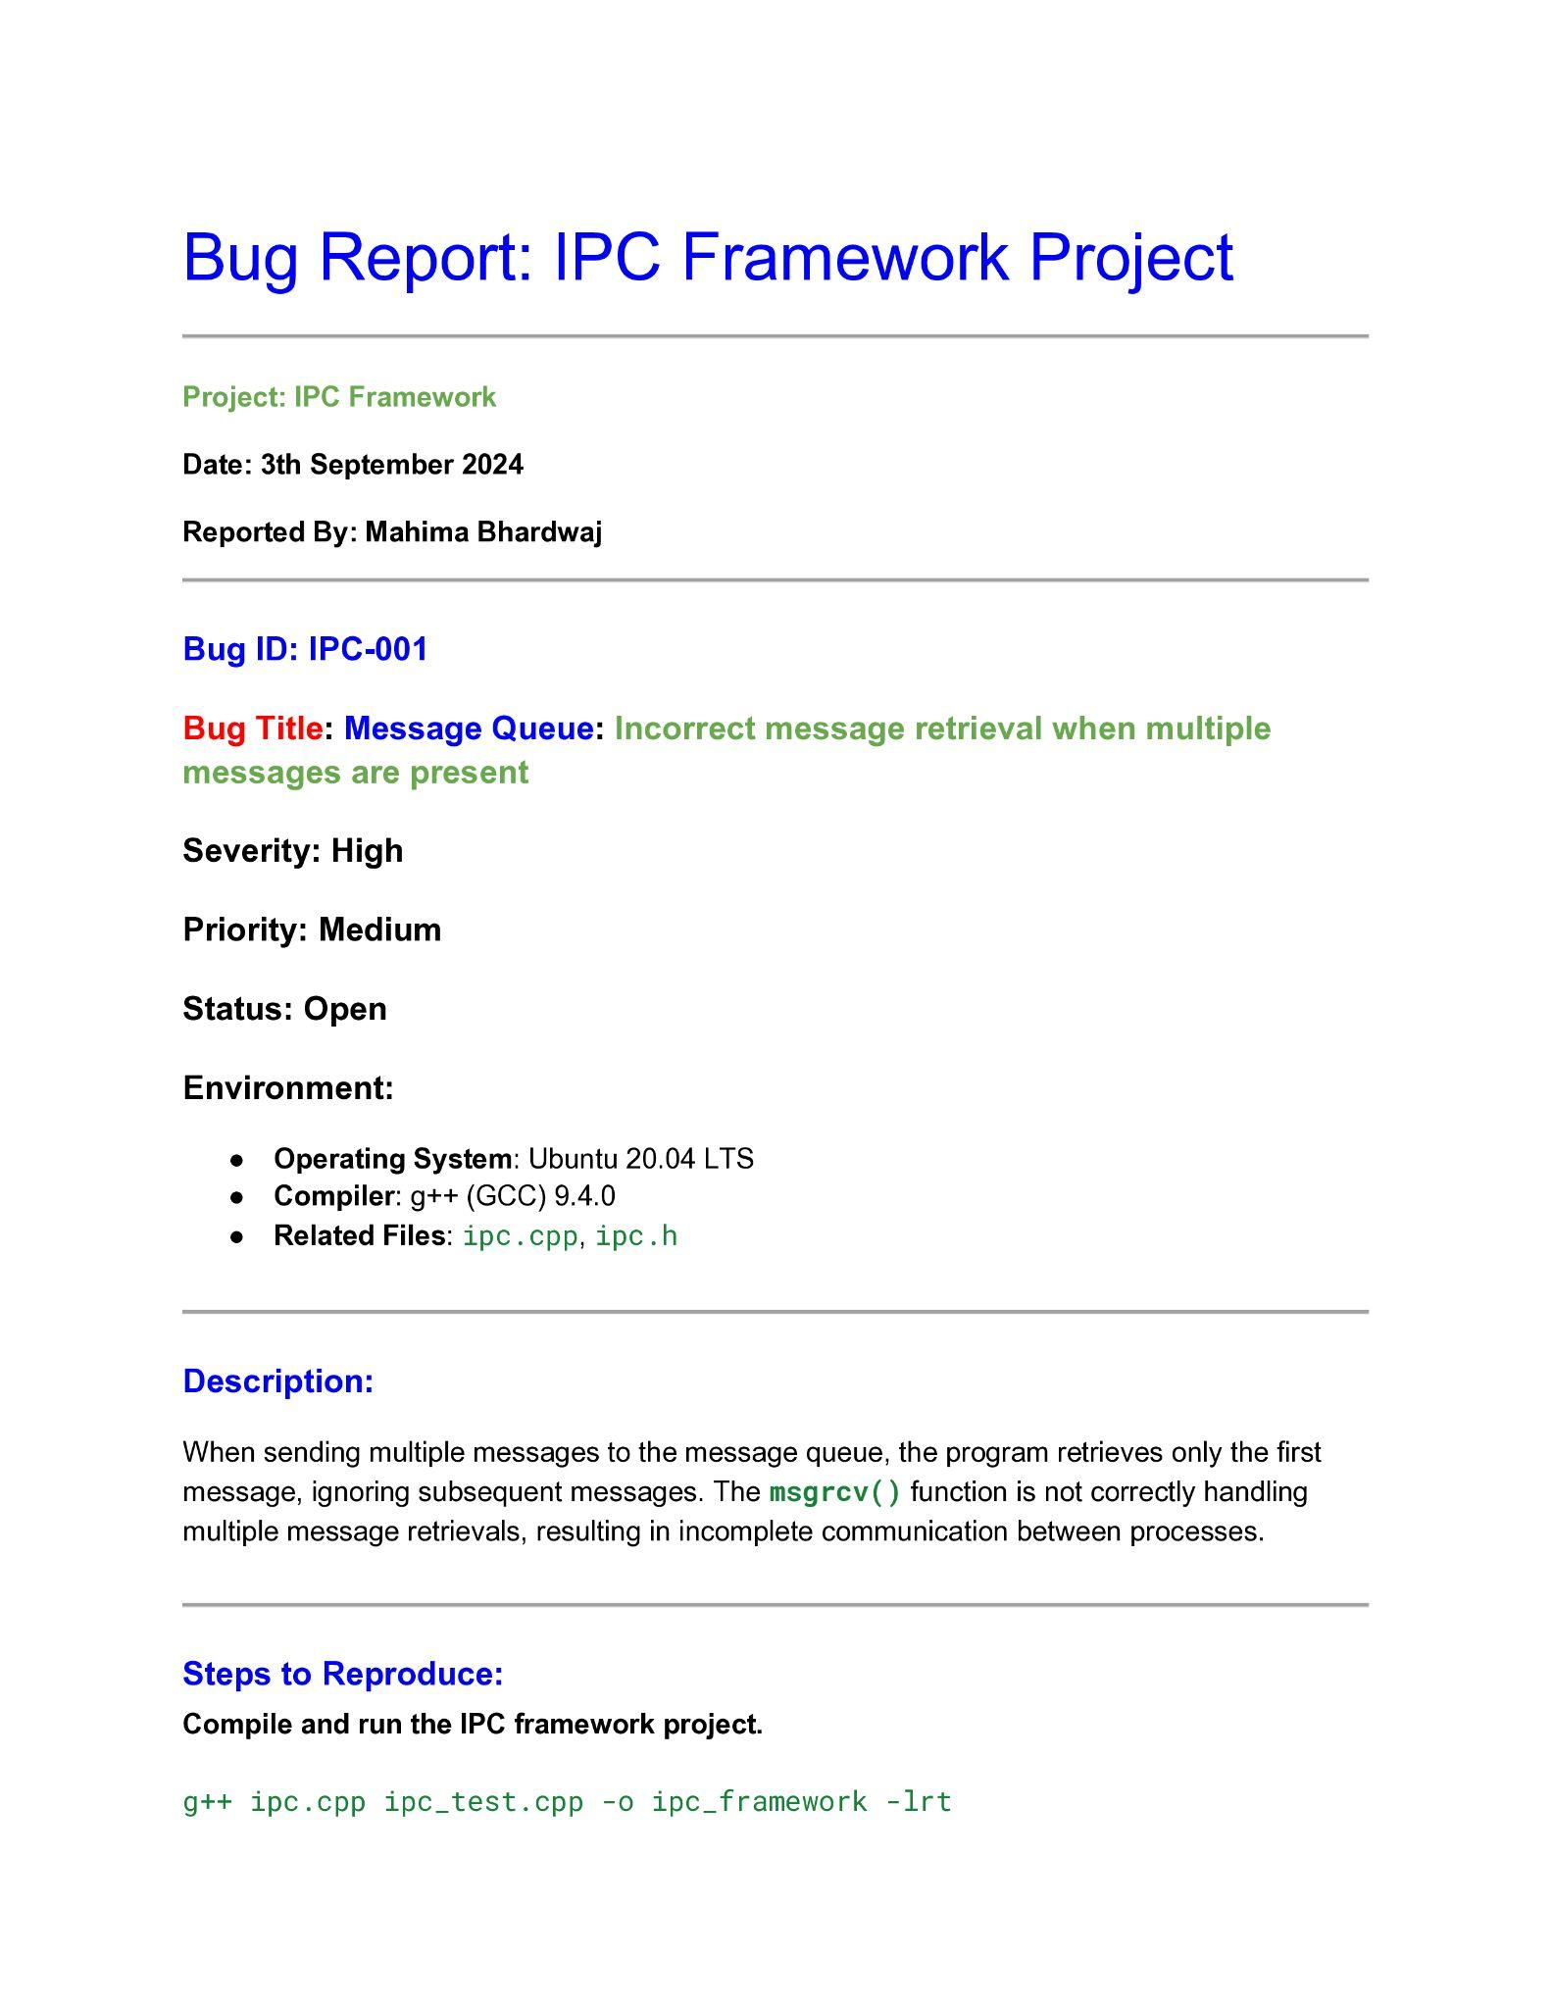

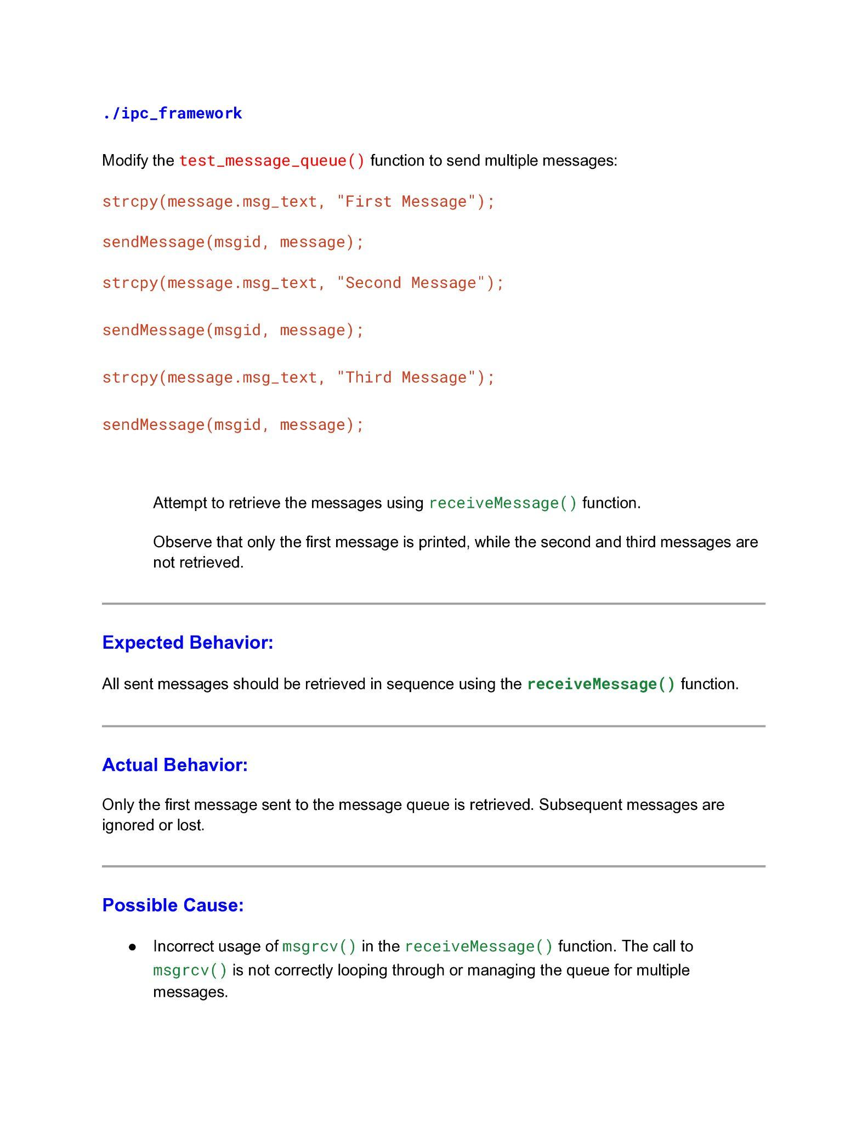



# **10. Documentation**

### Code Documentation:

Use inline comments and external documentation (e.g., Doxygen) to explain the purpose and usage of each module.

### User Guide:

Provide comprehensive instructions for developers on how to integrate and use the IPC framework in their applications.

# **11. Milestones**

### Phase 1

* Research and setup of the development environment.

### Phase 2

* Implementation of message queues.

### Phase 3

* Implementation of shared memory.

### Phase 4

* Implementation of semaphores.

### Phase 5

* Integration of IPC mechanisms into a unified framework.

### Phase 6

* Testing, debugging, and documentation.

# **12. References**

### POSIX IPC Documentation

* https://man7.org/linux/man-pages/man7/ipc.7.html

### Message Queues

* https://man7.org/linux/man-pages/man2/msgget.2.html

### Shared Memory

* https://man7.org/linux/man-pages/man2/shmget.2.html

### Semaphores

* <https://man7.org/linux/man-pages/man2/semget.2.html>

**This document outlines the requirements and provides a foundation for implementing an Inter-Process Communication (IPC) framework. The provided skeleton code offers a basic structure, which can be expanded to meet the full scope of the project.**

**THANK YOU**

* **WIPRO TEAM**
* **RPS TEAM**
* **SHWEATK SIR**
* **KIRAN VVN SIR**